**Title of Abstract in Arial Font: Size14 Point**

Author, A.A. 1, Underline Lead Presenter1, a, Third, C.C. 2

1 Institution, country

2 Institution, country

a e-mail address of lead presenter

The main text, like the author names used Times New Roman font, 14 point for the Author names and 12 point for the remainder of the abstract.

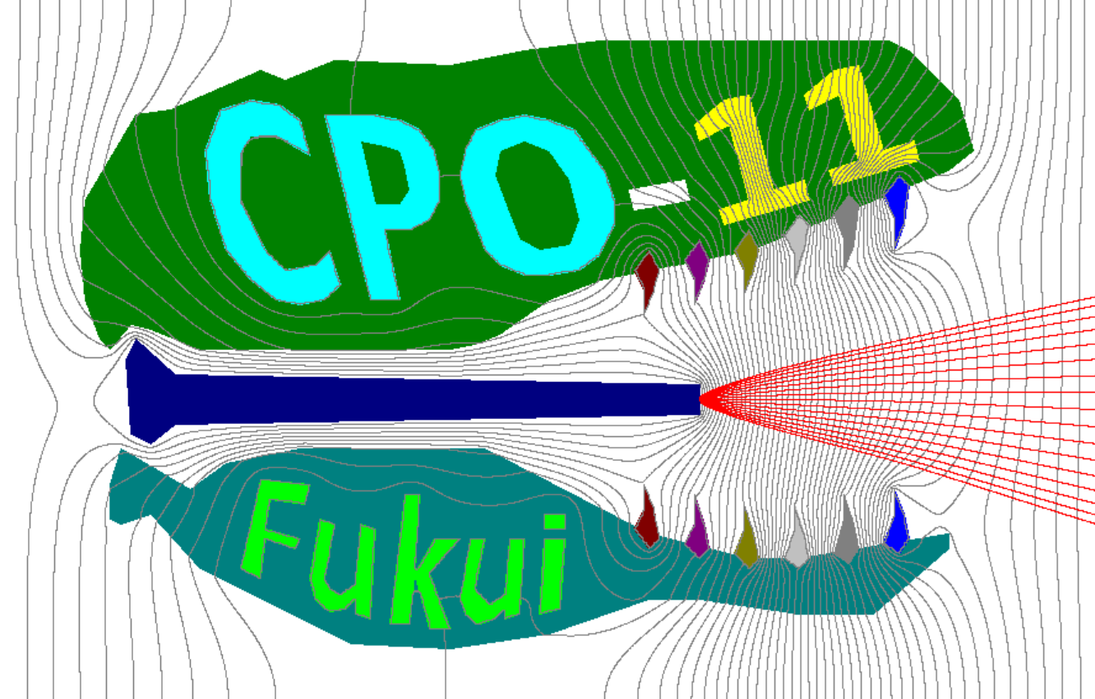

Use single-line spacing and leave a line gap between paragraphs. This helps your text to be read easily. If you would like to insert a figure you can do so (Figure 1). The limit for your abstract is one page.

The abstract deadline is August 30th [1].

**Figure 1.**  Electron beam breathing dinosaur.

References:

[1] First Author et al., Journal/Proceedings Name Vol. No., page No. (publication year).

Acknowledgments should be placed at the end.